

**Microsoft Azure AZ-900, Azure AZ-204 Certified**

**5+ Years** of experience in **Designing, Developing** and **Delivering** of **multi-tier applications** using web-based technologies like ASP.NET, .NET Core, MVC, C# and .NET Core API PowerApps With extensive knowledge of **Data Structure** and C# including **Collection**, **Threading**.

[**vsnehi@outlook.com**](mailto:vsnehi@outlook.com)

**+91 70226 96667**

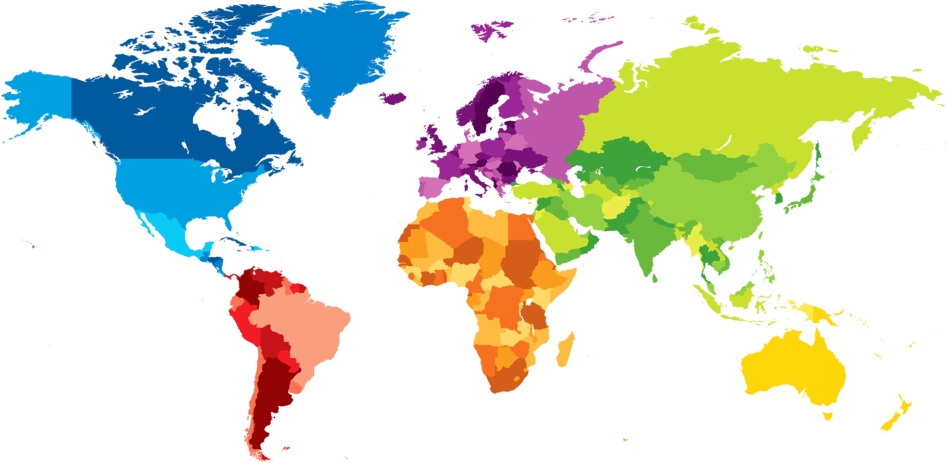 **GURUGRAM**

[**linkedin.com/in/vikramsnehi**](https://linkedin.com/in/vikramsnehi)

|  |  |  |  |  |  |  |  |  |
| --- | --- | --- | --- | --- | --- | --- | --- | --- |
| WORK EXPERIENCE  |  | | --- | | Project: Microsoft, MyHorizon .NET Full Stack10/2023 – current Capgemini IndiaResponsibility/TaskWorked on MyHorizon from scratch a model driven app.Worked on PowerApps, Dynamic 365, Microservices, Design Pattern, Web Resources development.Worked on C# .NET Core Web API, JS, NODE JS for Angular 18Worked with Azure, GIT, Json, REST API, XML, SQL, SP, NodeJS.Project: SEI, Homepage .NET Full Stack02/2023 – 09/2023 Capgemini IndiaResponsibility/TaskWorked on SEI HomePage Application from scratch.Worked on Angular 13, Services, Component, Module, IDS Component, and HighChart.js for UI development.Worked on Microservices, Web API, Design Pattern.Worked with Postman, swagger, Json, REST API, SQL, SP, NodeJS.Project: Table Games .NET Full Stack(**Old Comp. Name:** Scientific Games **India)** Light & Wonder 03/2022 – 01/2023, Bangalore Responsibility/Task  * Functional **Codefix**, added new Functions in application using **ASP.NET, .NET Core, Angular, entity framework, Bitbucket, NodeJS.** * Worked on MSSQL, Store Procedure, **SQL SERVER** for Database * Worked on **Microservice** **Architecture**, **MVC**, and **SOLID** **Principal**, **Factory** **Design** **Pattern**, **Repository Design Pattern** * Worked on **AngularJS** in Front END, **C#** as back end, **REST API** used for API.  Project: Road Maritime Services .NET Developer**(Client:** NSW Gov. of Australia**)**  Wipro Limited 02/2019 - 03/2022, Bangalore  Responsibility/Task   * Resolved **Critical Issues** and **Analyzed error logs** resulting in smooth rollout of client product using **C#** * Extensively worked on SQL, **C#, .NET MVC, LINQ ORM** * Good experience in developing applications with **Restful Web Services, Microservices and Design Pattern** * Worked on **NET Core, ANGULAR 8, HTML, CSS, jQuery, NodeJs** * Experience working **SDLC** with a blend of proficiency and leadership in AGILE-SCRUM.   **Academic Projects & GitHub**  [Crime Control System](https://github.com/er-vikramsnehi/crime) | ASP.NET MVC (04/2020)  [Video Interview](https://github.com/er-vikramsnehi/VideoInterview) System | ASP.NET with React  [Tour & Travel](https://github.com/er-vikramsnehi/Tour-Travel) | ASP.NET Web Form  [Github](https://github.com/er-vikramsnehi) | |  | | SKILLS  [This Photo](https://microcredentials.eu/outputs/microhe-outputs/) by Unknown Author is licensed under [CC BY](https://creativecommons.org/licenses/by/3.0/)   |  | | --- | | **.NET Core**  **ASP.NET**  **.NET MVC**  **Microservices**  **Rest API**  **Entity Framework**  **jQuery/ JS**  **Angular 17**  **Bootstrap**  **HTML**  **Design Pattern**  **MSSQL**  **Data Structure/Algorithm**  **Azure**  **CONTAINERS**  **DOCKER**  Educations | | B. TECH in Computer Science  Guru Nanak Dev Engineering College,  Punjab Technical University  2014-2018,  Ludhiana  BSEB- 12th Science  Zila High School Sahara  2012-2013  65%  BSEB – 10th Science  Zila High School  2010-2011  ` 64%  Training & InternshiP | | * 6 Months .NET – IBM-KVCH * 6 weeks internship – mta india * 6 Weeks Cloud computing -KVCH * Training C & C++ -- NIIT   CertificaTION & AWARDS | | * [SQL BASIC](https://www.hackerrank.com/certificates/f07bea69c026), [SQL Intermediate](https://www.hackerrank.com/certificates/4335f15d4fbf), [Problem SolvinG Basic](https://www.hackerrank.com/certificates/74fc8b61506e), [Problem Solving2](https://www.hackerrank.com/certificates/7880acb37151), [HTML](https://www.techgig.com/skilltest/certificate/Vmo4MHRpR0lXRDJwRVd1QW9XVEkzUT09), * [AZURE AZ- 900](https://learn.microsoft.com/en-in/users/vikramsnehi/credentials/d0c272f995c96818) * AZURE AZ-204   INTERESTS |   Gym  World news  Learning new Tech |  |